Standing a HUBzero instance up on Amazon Marketplace

Prerequisite Amazon Marketplace Account:
1. Navigate to: https://aws.amazon.com/marketplace/
2. Click on Create a new account – follow instructions.
*This may take up to two hours for creation.
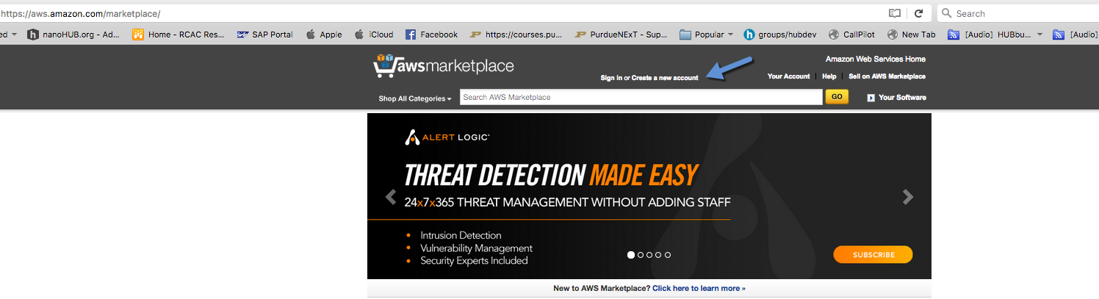

Logging In

Navigate to: https://aws.amazon.com/marketplace/
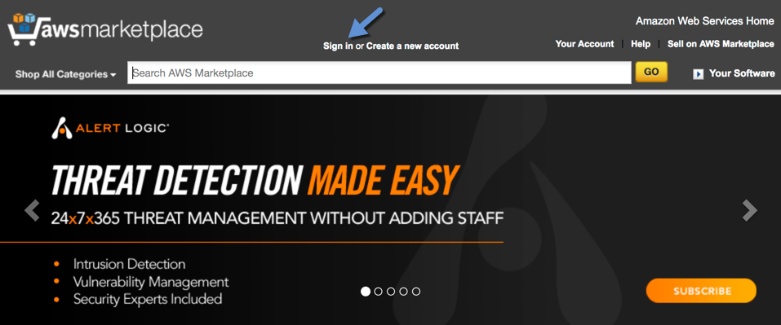

Provide login credentials to the Amazon Web Services log in page.
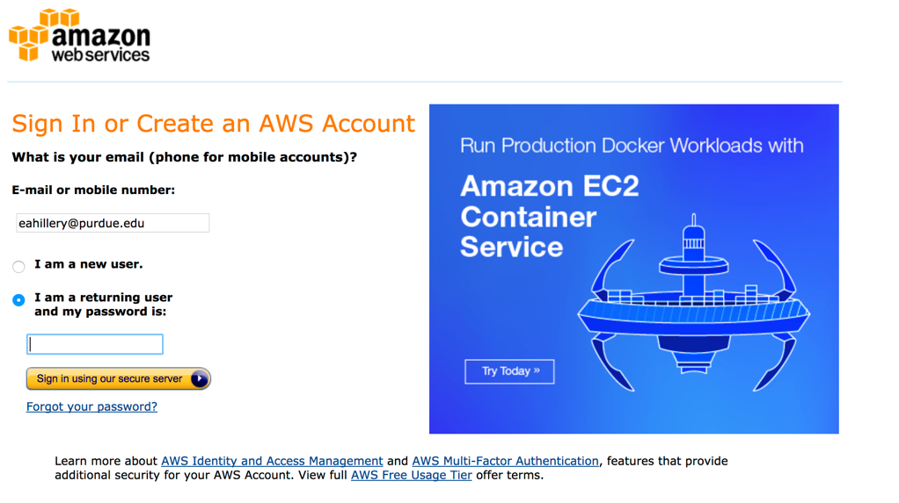

Click on the Amazon Web Services Home Link.
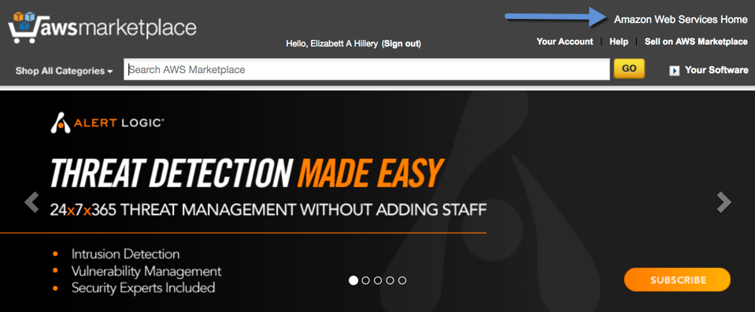

Click on Sign in to the Console.
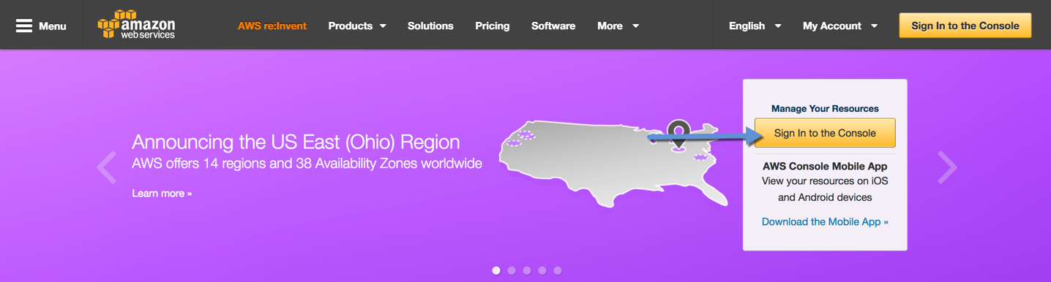

Creating a Key Pair – (Perquisite)

Click on the EC2 icon or EC2 located under AWS Services / Compute.
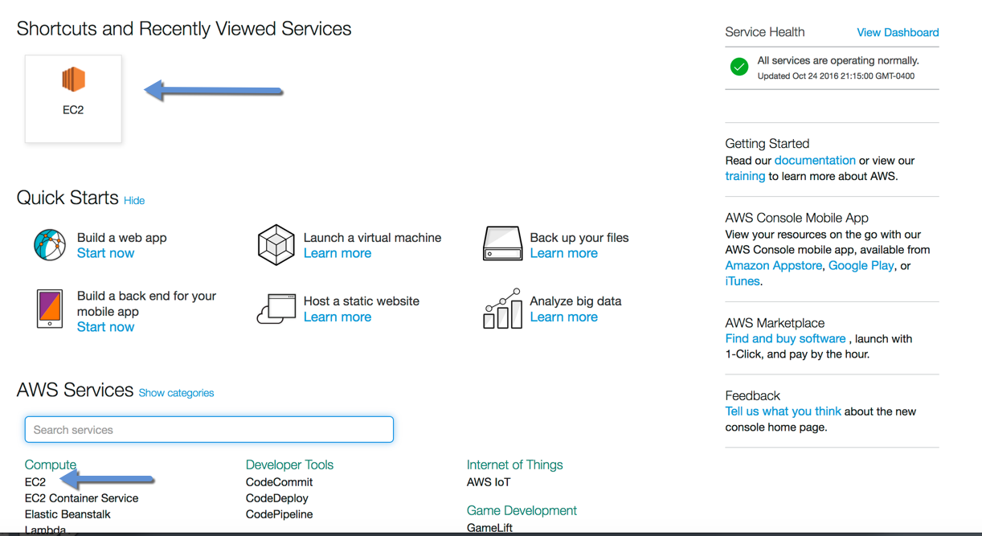

Navigate to Key Pairs located under the EC2 Dashboard / NETWORK & SECURITY.
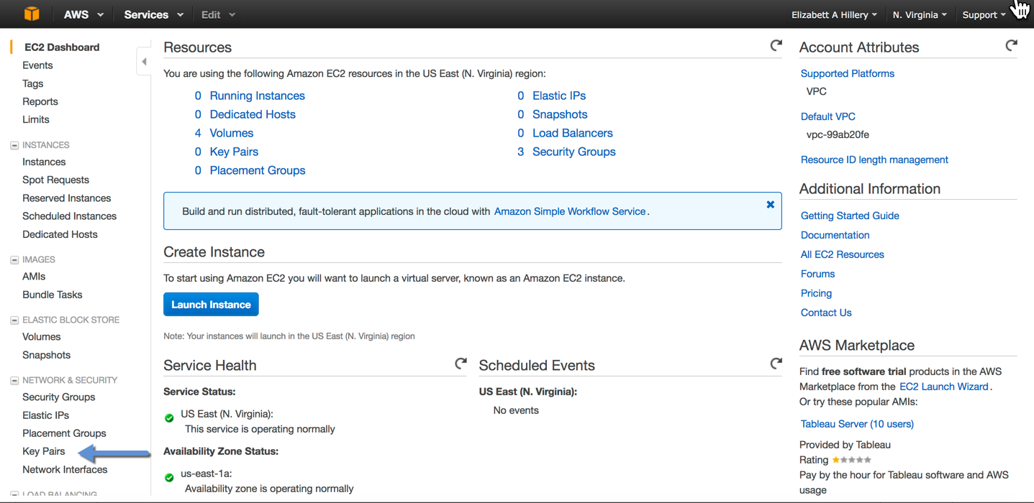

Click Create Key Pair.
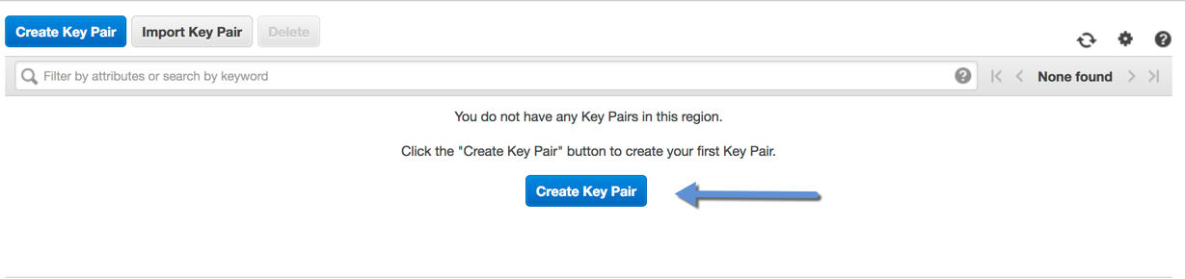

Enter Key Pair name – User’s choice.
Click Create.
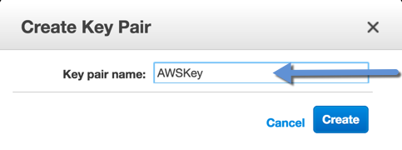

Click Save File in a destination that can be found later.
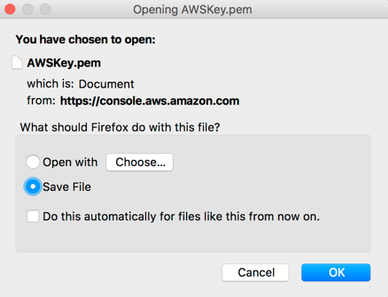

Note Key pair name for future use.

Note N. Virginia or where Key Pair was created.

Creating Instance

Return to Console Home by clicking on the following icon, located in the upper left corner.

Click on the EC2 icon.
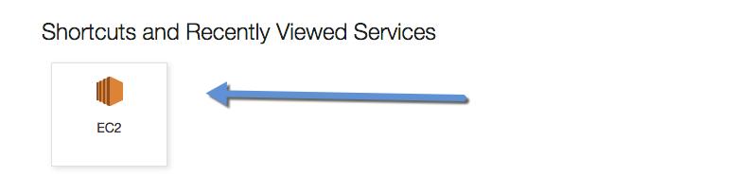

Click on Find more software on AWS Marketplace (Lower Right Corner).
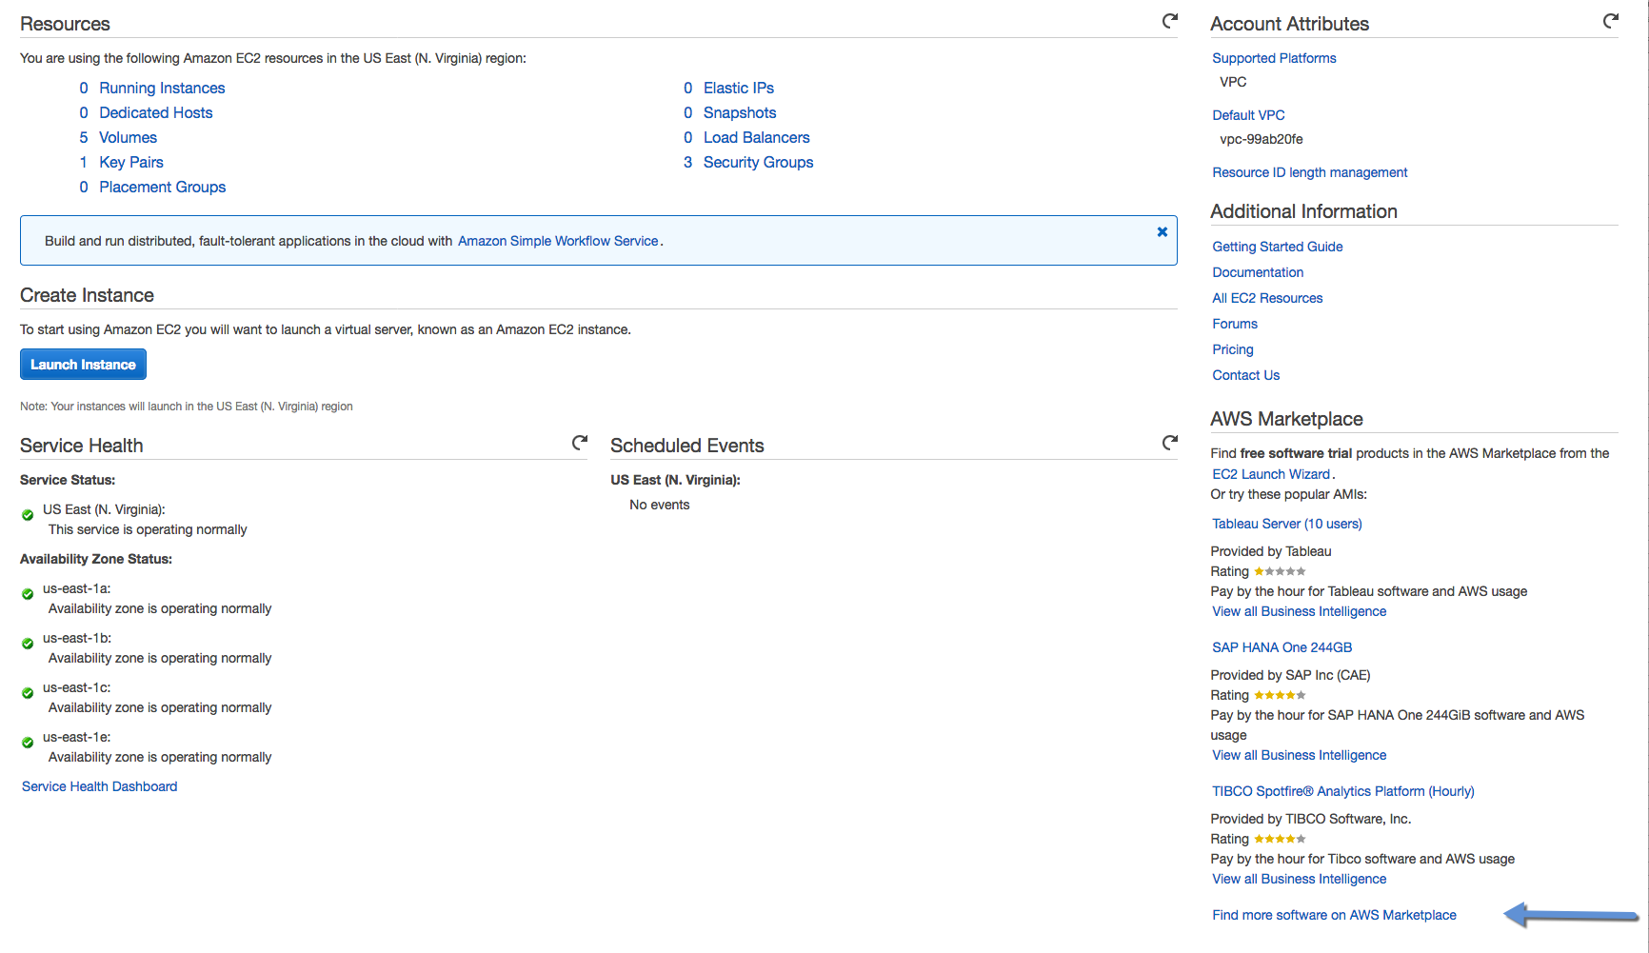

Enter hubzero in the Shop All Categories and Click Go.
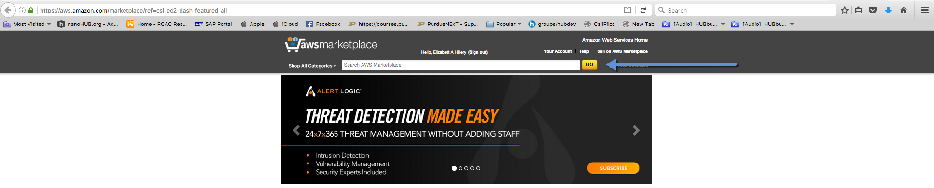

The following page should appear.
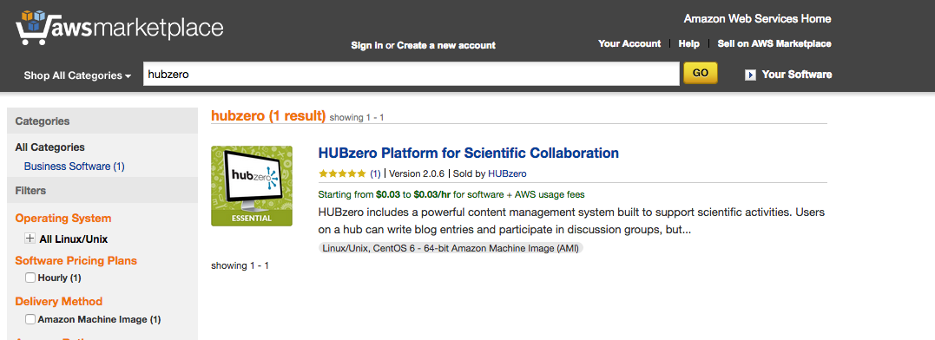

Click on HUBzero Platform for Scientific Collaboration.
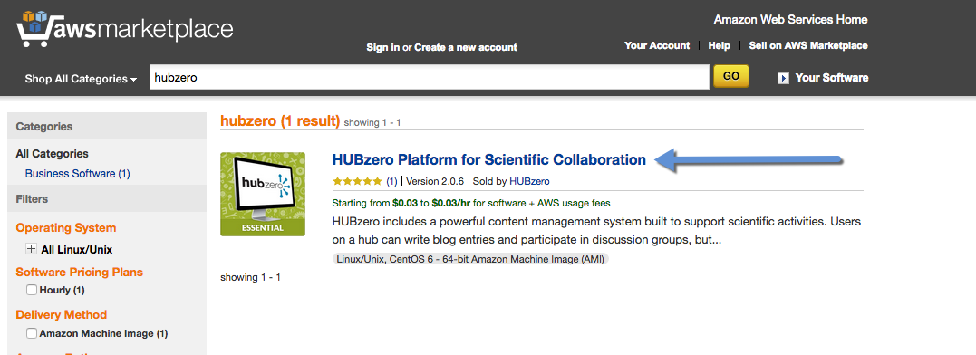

Click Continue.
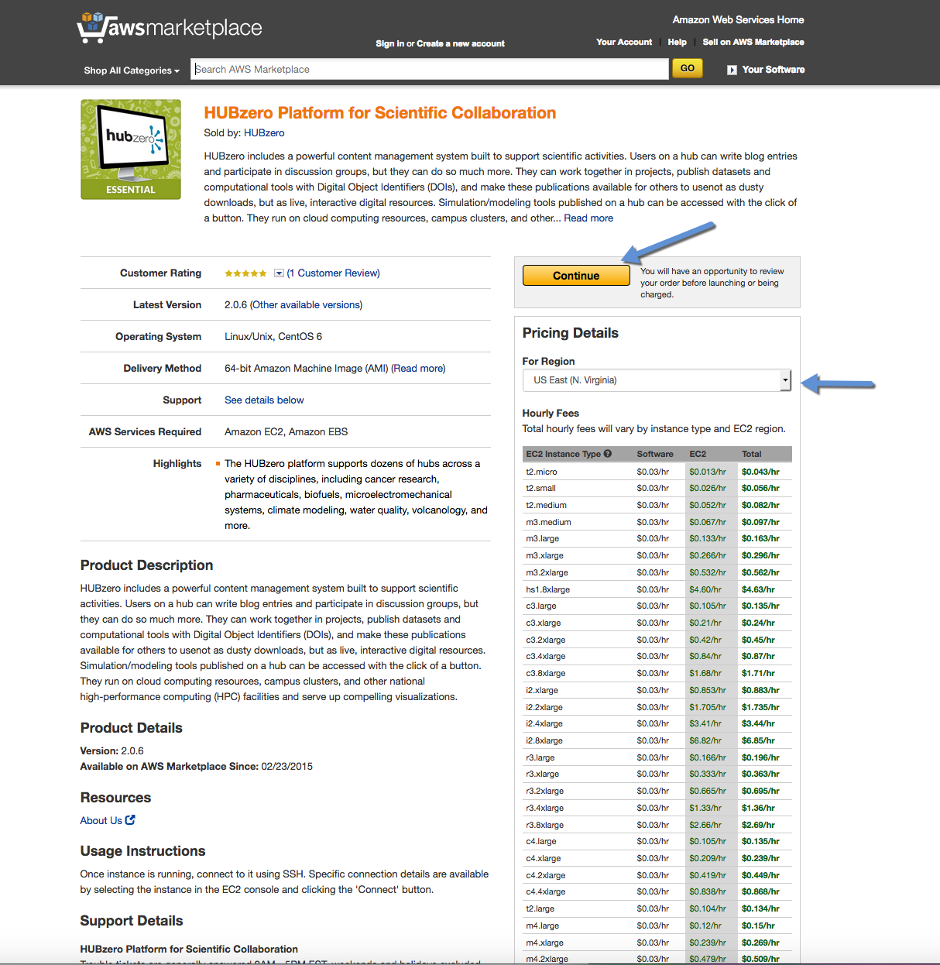

Click the 1-Click Launch.
*Notice there may be an error to Please select a key pair.
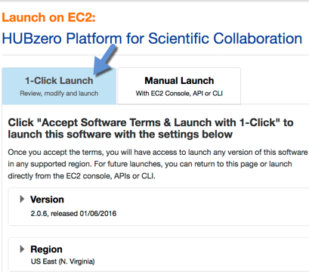

Verify t2. Micro instance is selected.
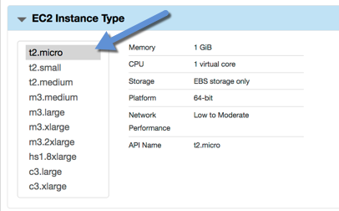

Scroll to the bottom: Verify Key Pair is present from above.
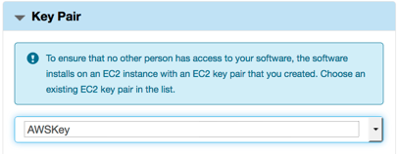

Click Launch with 1-click.
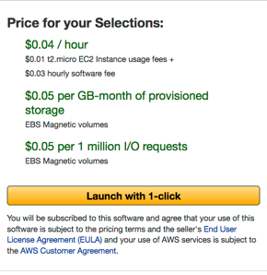

SUCCESS – The following page will appear with instance details.
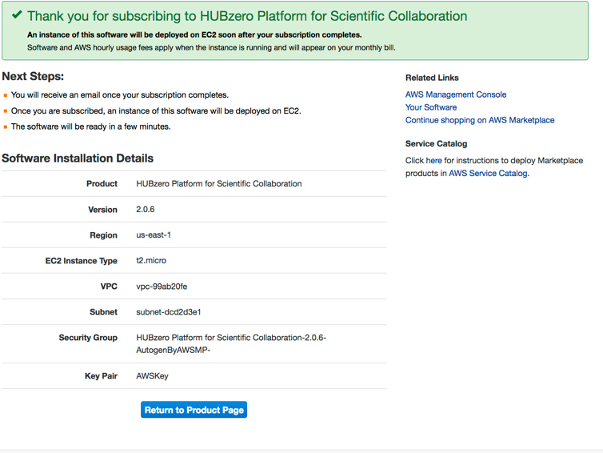

Click on Amazon Web Services Home.

Click on Sign in to Console.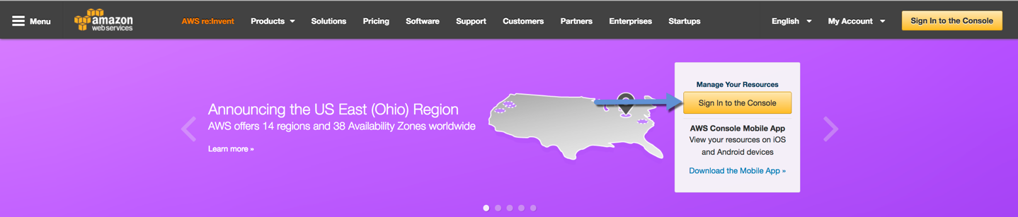

Click on the EC2 icon or EC2 located under AWS Services / Compute.
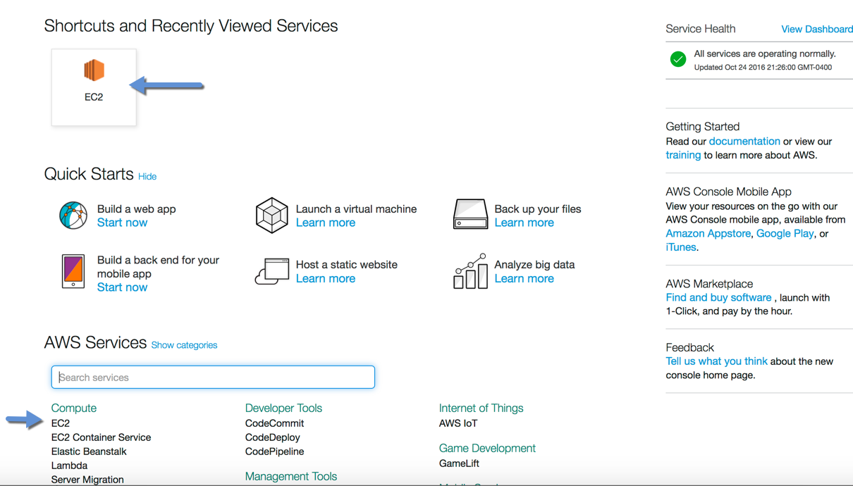

Click on Running Instances.
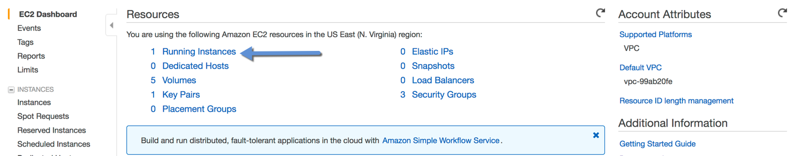

Click on Instance ID – Note ** Status Checks**.
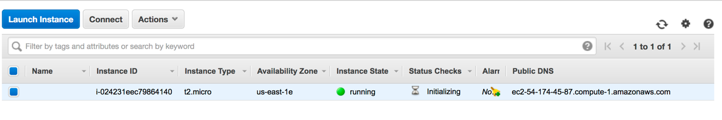

When the instance is running (Instance Status) your hub is ready.
Copy the Public DNS entry – this is the URL to your new hub.
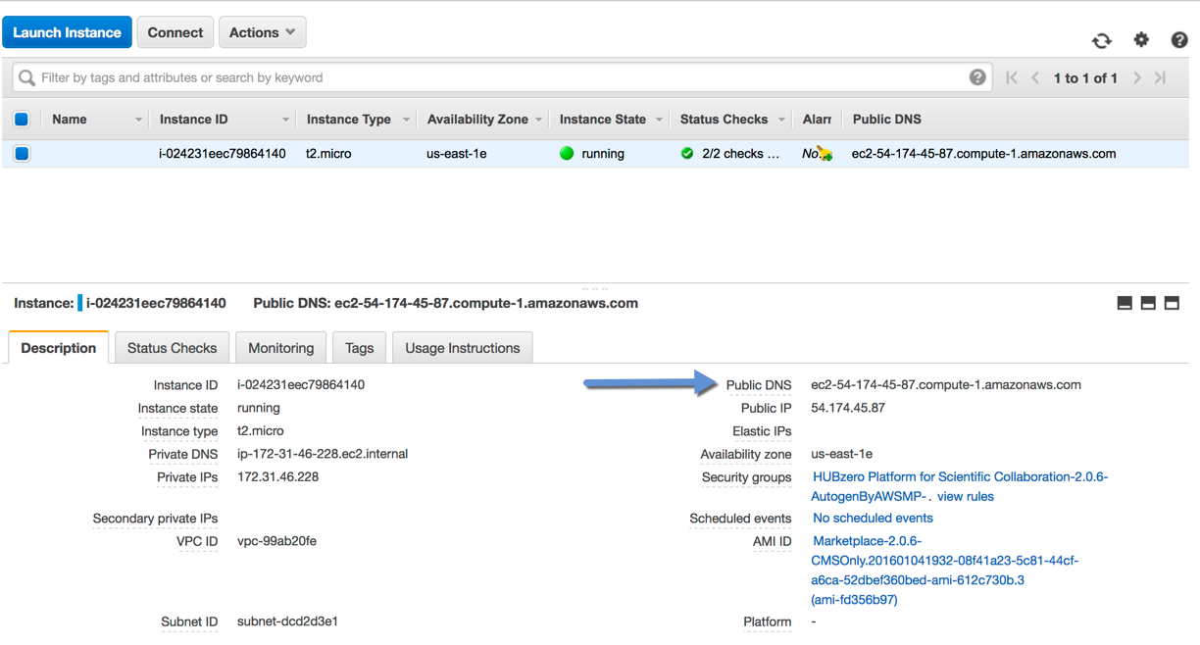

Paste URL into a browser.
The following page will appear.

Note the following information:
Homepage of your new hub.
Adminstrator URL – to be used next.
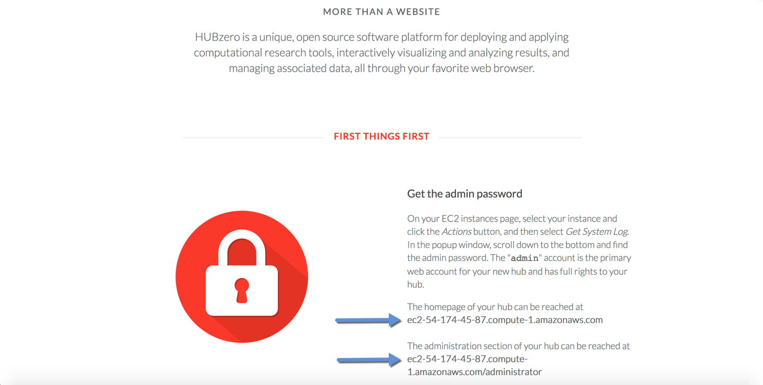

SSH access information – Use if you want to secure SSH access.
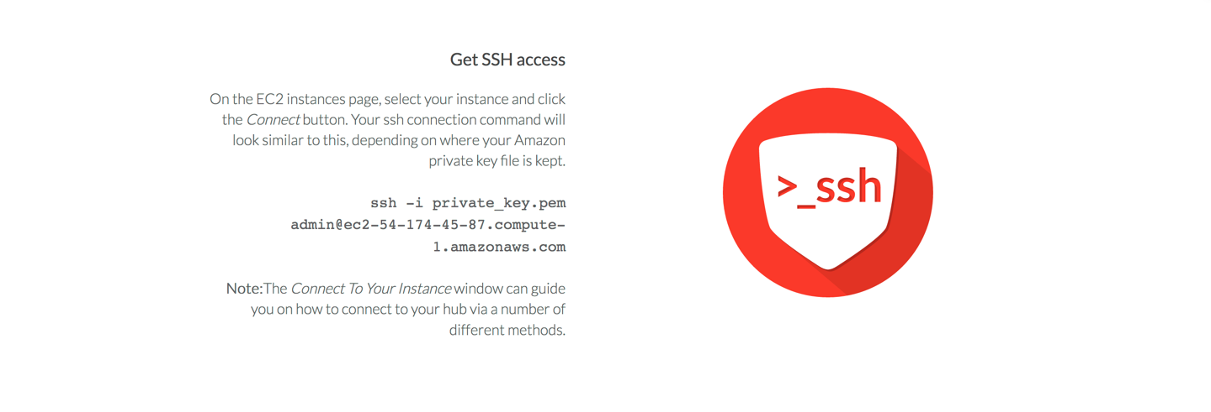
Jump to Your Hub – WAIT – we will do that in a few steps.
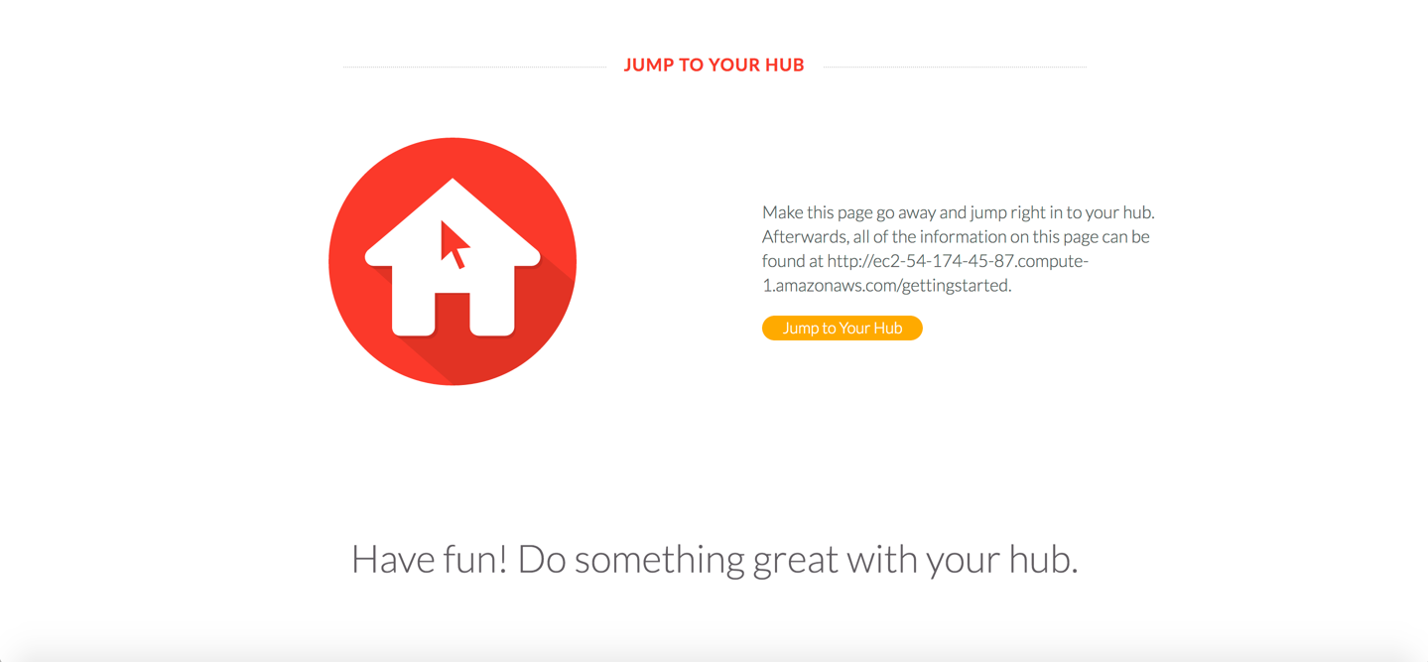

Navigate back to EC2 tab. (Go back to previous tab).

Selecting the new instance.

Click on Actions / Instance Settings / Get System Log.
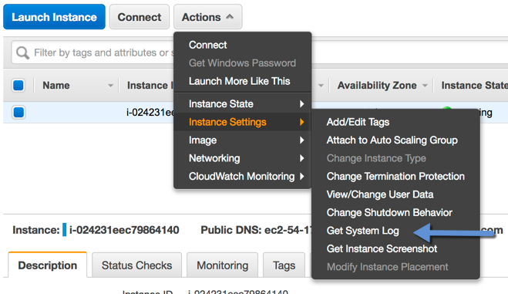

Secure Admin Password by scrolling to the bottom of display.
Copy Password or note somewhere.
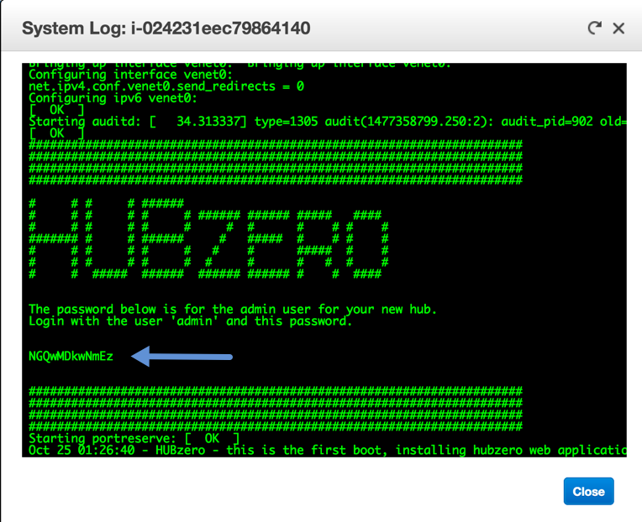

Navigate back to your Instance (hub instance tab).
Now you are ready to Click Jump to YOUR hub button.
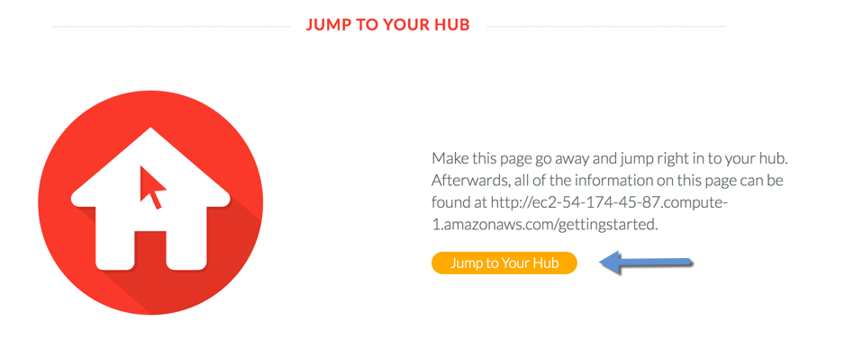

Review details on Getting to Know Your Hub.
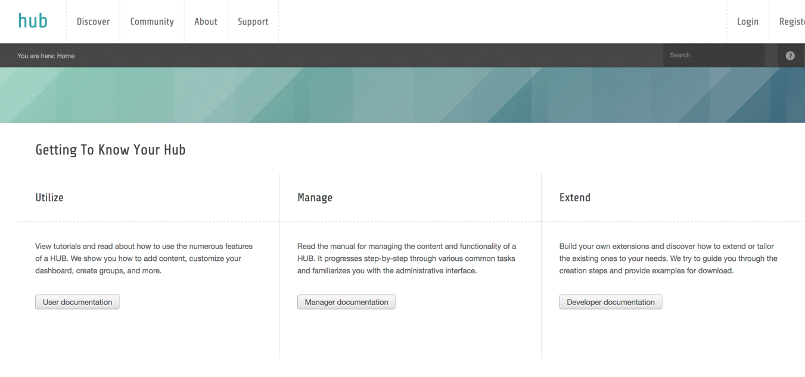

Review details on Setting Up Your Hub.
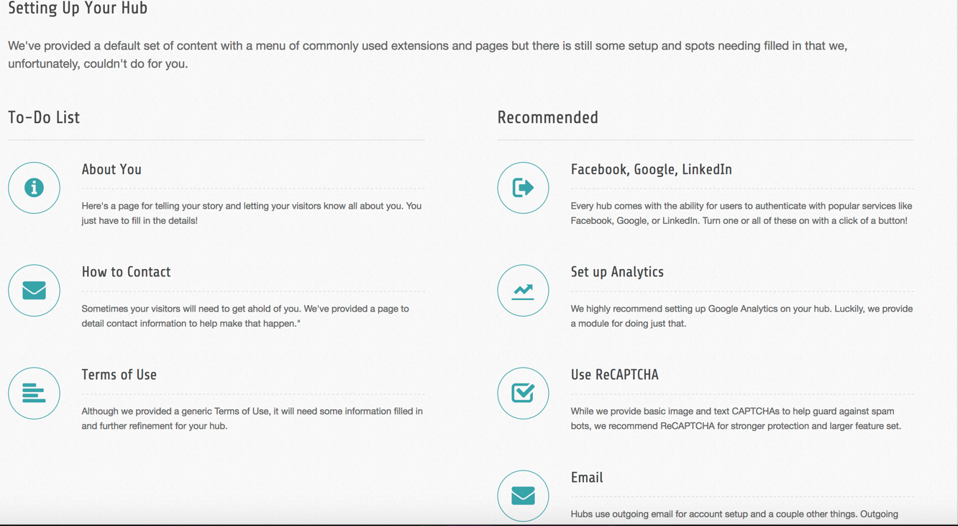

Navigating to the Administration.
Click on Administration.
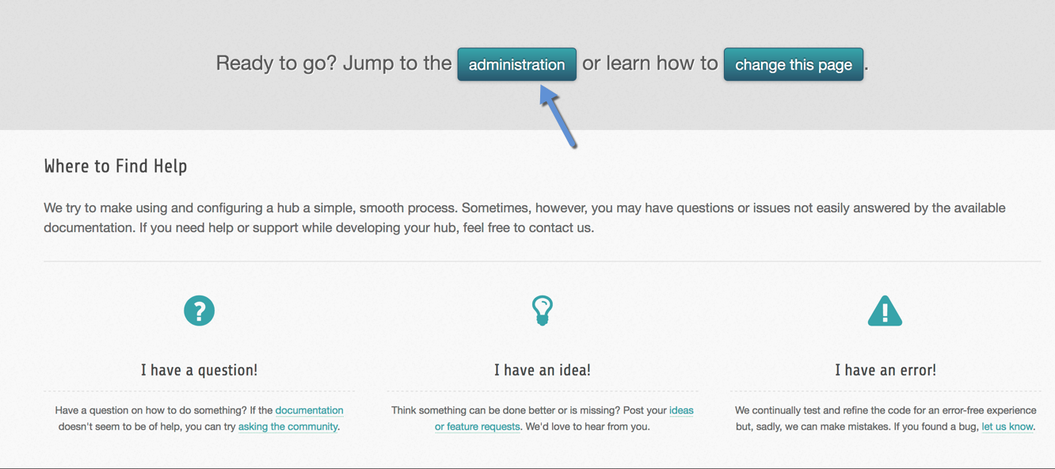

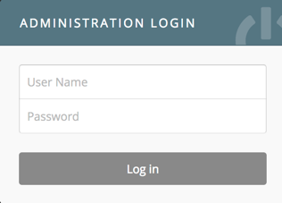

User Name: admin
Password: Password obtained above.
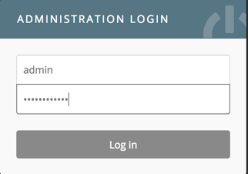

If the following error happens.
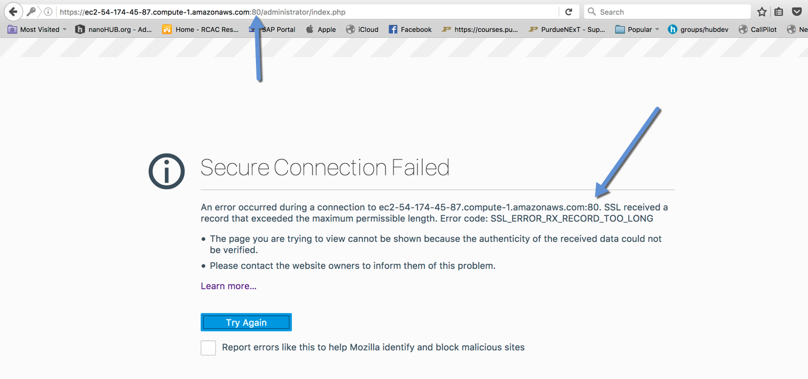

Remove the :80 from URL and refresh the browsers.

Click on Advanced.
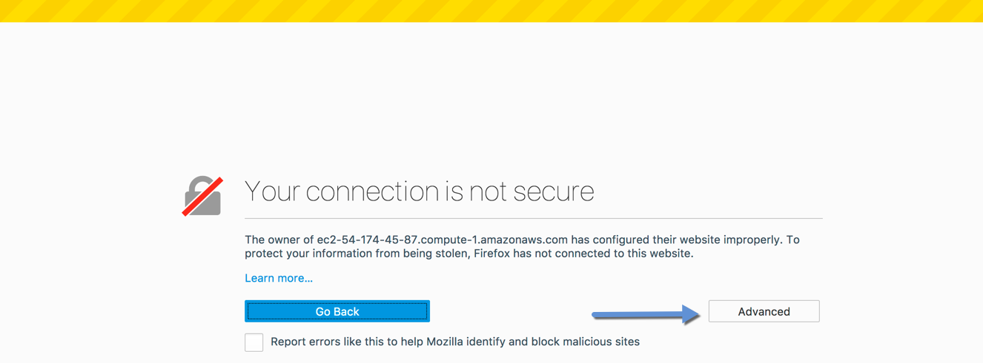

Click on Add Exception…
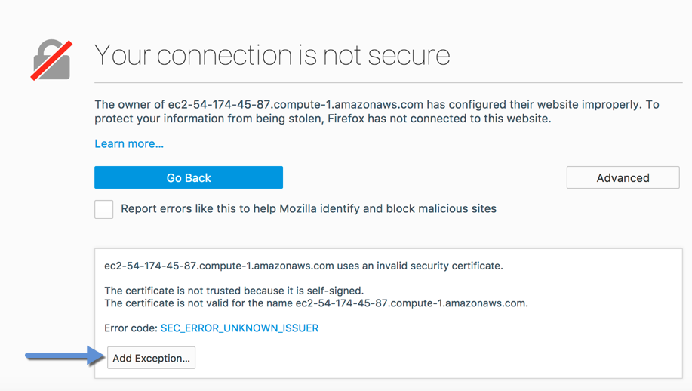

Click Confirm Security Exception.
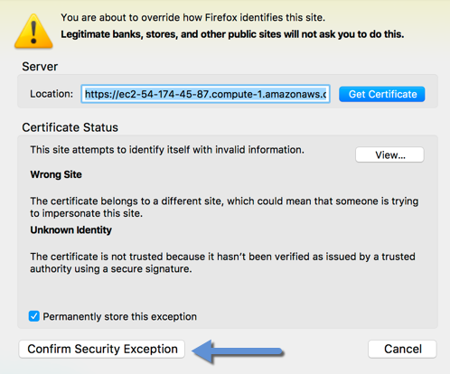

User Name: admin
Password: Password obtained above.
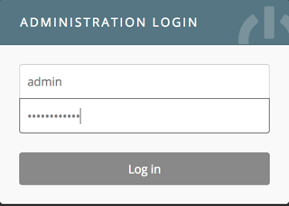

SUCCESS: (Let’s review dashboard)
